Leanne – Trent – Trent Meeting Pre-Report: 9 / 22 –/24

**Action Item1: Loom is on Github**

**Action Item2: Recruitment update**

In the past two weeks we have had 2 loom participants and 2 RL participants. This means Loom requires 3 more until completion.

The two participants we had for RL were of middling expertise. Both had played a decent amount but had very low rank. They found one of the flyers that were placed around Ryder Hall, and Gabi tells me the calls to local universities have not proved to be fruitful yet.

**Action Item3: RL Updates**

This period was productive however we had to spend some time getting the three new members back up to speed and assigned to their different roles on the project. After meeting with everyone, we decided that Nitika and Shravan are going to be working more with the CGP analysis and Vikram is going to be working with Ashwini on the quiet eye.

**CGP Update:**

As per our last update on RL on the CGP analysis, we wanted to do two primary things:

1. Update our post-processing analysis to record more than just 3 combo objects and consider all of the objects on the frame as potential CGP. We were able to achieve this:

1. The next step will be to use the percent avg use of these CGP combinations to direct a more systematic method of choosing the combination based on a weighted choice. We will be pushing forward with this this week.

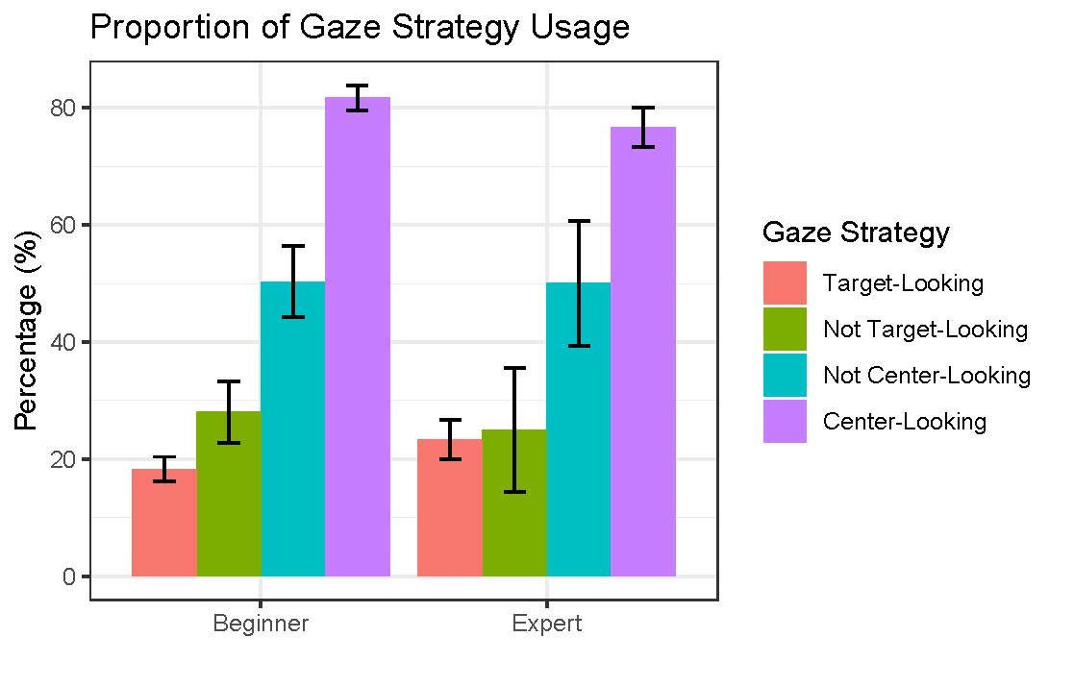

This result was calculated early on, and I personally had never taken a closer look at the outcome. Recently, when preparing the data for the CCN poster I wrote some code that would reanalyze this result. What I found was evidence that this data might not be entirely accurate. We are not completely sure at this moment why the results calculated by me and Ashwini are different, however it is most likely due in part to our analysis method. Ashwini, took a very broad approach by calculating each **individual** frame to be one of these categories and then used the raw percentage amounts of each to generate this data.

I use a more focused approach by calculating the individual gaze strategy durations, and then using the average time values to calculate my result. Ashwini and I have attempted to understand the difference but have thus far been unable. We both seem to be right.

I asked Nitika and Shravan to perform an independent analysis regarding this question which they have now done and found my result, using methods closer to the one that Ashwini used. **At this point I am forced to reconsider a lot of our data up to this point and have started a full audit of the post processing pipeline**. Just because our data is indicating this different result does not mean that it is correct. Others and I have watched a lot of video of participants with their gaze and I never saw the amount of target-looking as our data seems to indicate. Unfortunately, that first-person observation matched up with what the incorrect analysis found so I never questioned it.

**LAST MINUTE UPDATE (got this right as I am sending out report):**

Shravan found that there is a large buffer around the bounding boxes for each object. Watch the attached video to see -> Blue color means that the data thinks that participant is looking at an object and Red means the data thinks that they are not. The video clearly shows that a lot of time that participant is not looking at objects, the data thinks it is. We will change the buffer back to normal and rerun data to see what changes.

**Quiet Eye Update:**

Last update on Quiet Eye we had just finished our first cleaning of a single participants data. Which looked like this:

Each row is a goal and comes with an attached Duration and Onset measure time. Some of these times were a bit low but for the most part this data looks as it should. When this code was run on the rest of the participants we do not see this result.

¼ - 1/3 of the data times for Duration and Onset are zero. Shown Below: (The 50 and 100 is the threshold we are using. Both were used based on our old threshold and the new one advised by Leanne)

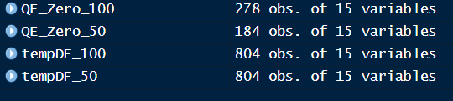

If we filter the 804 observations to only those above 100ms, constituting a fixation, then half of these results are taken out. At this point I am not satisfied with that amount lost data, and I want to explore why this is happening for rest of these participants unlike the initial one that I showed above. There really should not be a single 0 at all, so that requires a more specific investigation.

**Action Item4: I did not have a chance to look at Loom data for sequencing.**

**Action Item5: I have not had a meeting with Massa.**